Online Boutique is a cloud-first microservices demo application. The application is a web-based e-commerce app where users can browse items, add them to the cart, and purchase them.

Architecture
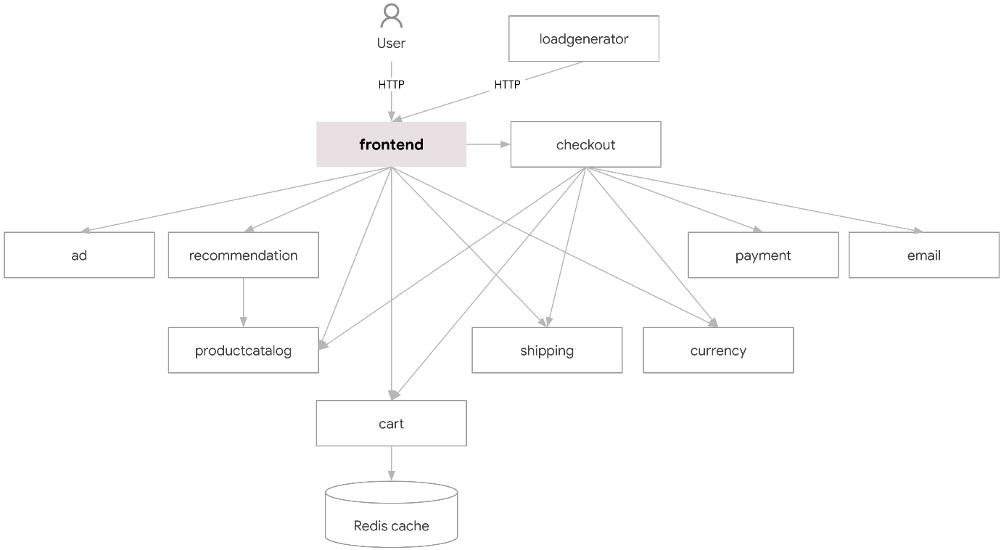
Credit: Google Cloud
Steps1:
Ensure you have the following requirements:
  - Google Cloud project.
  - Shell environment with gcloud, git, and kubectl.
Step2: Clone the latest major version.
git clone --depth 1 --branch v0 https://github.com/GoogleCloudPlatform/microservices-demo.git
cd microservices-demo/
Step3: Set the Google Cloud project and region and ensure the Google Kubernetes Engine API is enabled.
export PROJECT_ID=<PROJECT_ID>
export REGION=us-central1
gcloud services enable container.googleapis.com \
--project=${PROJECT_ID}

Step4: Create a GKE cluster and get the credentials for it.
gcloud container clusters create-auto online-boutique \
--project=${PROJECT_ID} --region=${REGION}
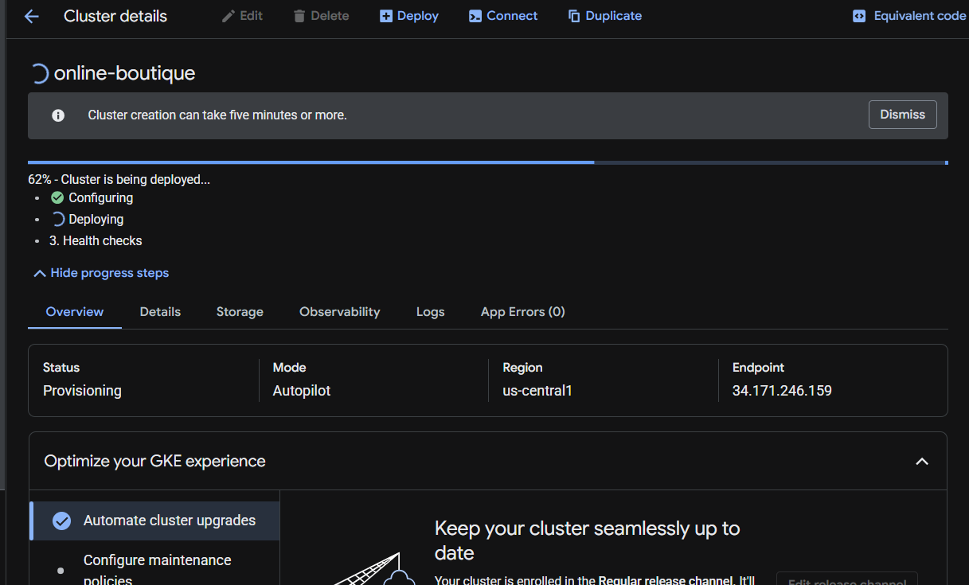

Step5: Deploy Online Boutique to the cluster.

kubectl apply -f /home/student_01_8c606f2fafb7/my_project/microservices-demo/release/kubernetes-manifests.yaml

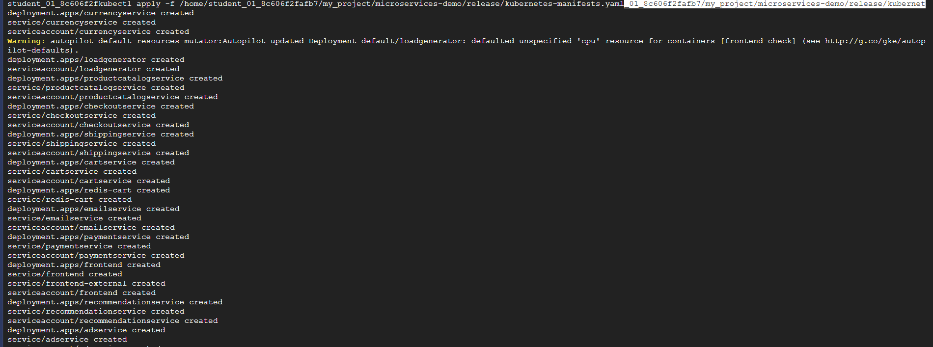

Step 6: Wait for the pods to be ready.
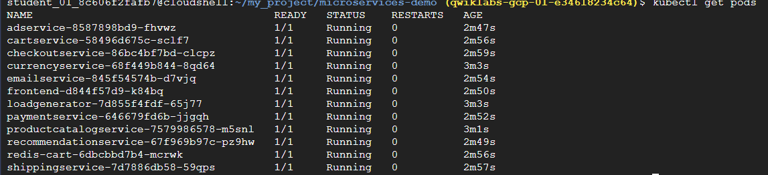
Step:7 Access the web frontend in a browser using the frontend's external IP.

http://35.188.139.22
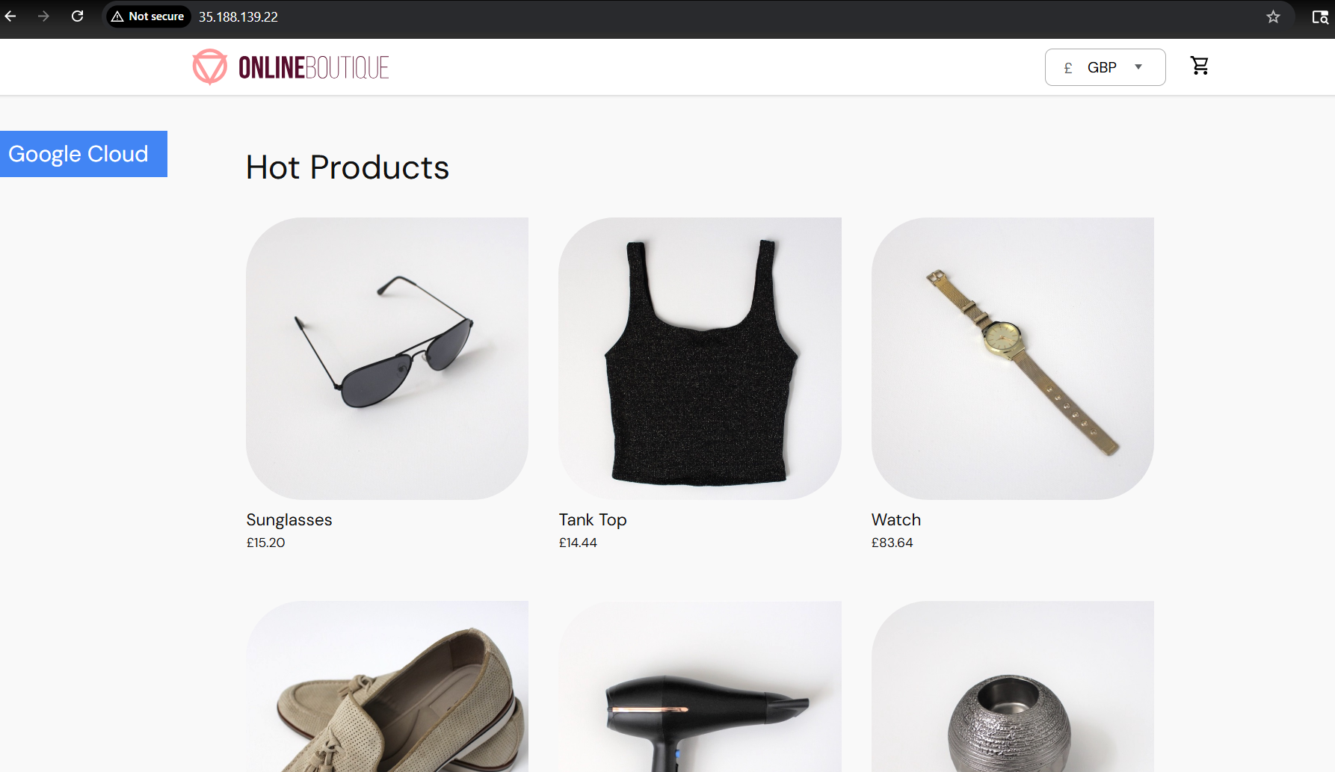
Step8: Once you are done with it, delete the GKE cluster.
gcloud container clusters delete online-boutique \
--project=${PROJECT_ID} --region=${REGION}
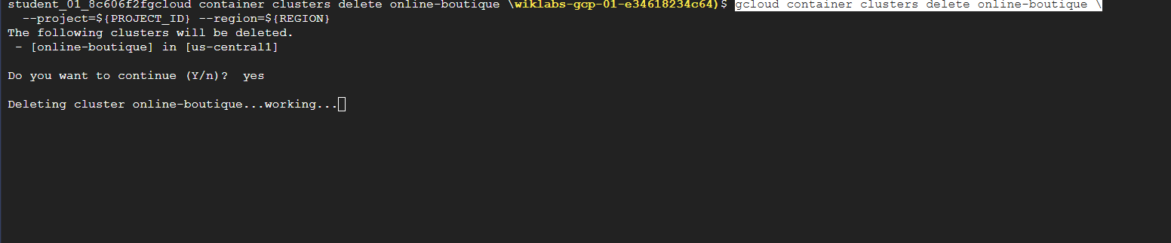
Note: I used the Google cloud repo to perform and complete this project:
Github link: https://github.com/GoogleCloudPlatform/microservices-demo

